Army Cricket Association

President: Major General James Illingworth OBE

|  |  |  |
| --- | --- | --- |
| **Chairman:**  Brigadier Jonathan Bartholomew OBE  Head Overseas and Training Region Building 25, Waterloo Lines,  Imber Road  WARMINSTER  Wiltshire, BA12 0DJ  Civ: 01985 222860  Mil: 94381 2860  Mob: 07780 492800  [Jonathan.Bartholomew359@mod.gov.uk](mailto:Jonathan.Bartholomew359@mod.gov.uk) |  | **Secretary:**  Lieutenant Colonel (Retd) Mike Thornley  Army Sports Control Board  The Mackenzie Building  Fox Lines, Queens Avenue  ALDERSHOT  Hampshire GU11 2LB  Civ 01252 787074  Mil: 94222 7074  Mob: 07786 094178  [mthornley@ascb.uk.com](mailto:mthornley@ascb.uk.com)  <https://cricket.armysportcontrolboard.com> |
|  |  | 31 March 2021 |

**GUIDANCE FOR THE ASSURANCE OF CRICKET IN THE ARMY – THE ARMY CRICKET ASSOCIATION (ACA) SPORT SAFETY MANAGEMENT PLAN (SSMP) – COVID 19 UPDATE V2**

A. Army Sport Control Board Directive.[1]

B. AGAI Volume 1 Chapter 5 Sport (updated November 2020).

C. Guidance for the Assurance of Army Representative Sport[2] ASCB/ACOS/Pol/23/04 dated 21Jun 18.

D. Army Cricket Handbook (ACH) 2021-22.

E. JSP 375 Pt.1 (V1.0 Jun 17) – Mngt of Health and Safety in Defence: Directive (Jun 17).

F. JSP 660 – UKAFSB Guidance and Direction.

G. Army Command Standing Order (ACSO) No 3216 – The Organisation and Arrangements for the Management of Safety and Environmental Protection in the Army. Issued May 2018.

H. MCC Laws of Cricket.

I. ECB Directives for bowling, fielding, young persons and fitness of ground due to weather and light.

J. CB and PCA Guidance: Head Protectors / Helmets.

K. ECB COVID 19 Return to Play Guidelines and Directions March 26th 2021

|  |
| --- |
| **COVID-19 Update**   1. The ACA Sport Safety Management Plan (SSMP) was originally published on 20 Feb 20. This updated version reiterates the information contained in the previous edition but also includes specific direction and guidance for Army Cricket in response to the COVID-19 situation. Annex B contains the necessary direction and guidance to facilitate a safe return to cricket (both for training and matches) within the Army. This includes detail from both the Chain of Command and our National Governing Body (the ECB). Those involved with, and responsible for, the planning and delivery of cricket within the Army (Committee Members, Managers, Coaches and Team Captains) at **all** levels of cricket (Army, Corps and Unit) are to ensure that they comply fully with this SSMP and pay particular attention to the COVID-19 specific direction contained in Annex B. |

**Introduction**

1. Ref A, provides direction for the conduct and delivery of sport in the Army. This includes the assurance, compliance and governance of sport in accordance with Ref B. Ref C provides further guidance and specifically tasks the Chairman of the Army Cricket Association (ACA) to:
   1. Ensure the delivery of the Cricket, through the ACA Executive Committee, is in accordance with the policy and guidelines stipulated by England Cricket Board[3] together with the direction in Ref C.
   2. Ensure that cricket has an effective assurance mechanism to provide a safe environment.

**Sports Safety Management Plan (SSMP)**

1. This document provides a framework SSMP for Cricket within the Army and identifies key roles and responsibilities for those personnel involved in the delivery, assurance and governance of cricket, within their organisation. As such it is a supporting document to the Army Cricket Handbook (Ref D) which is published annually (or as required).

**Unit Level Cricket**

1. In common with other sports, the Chairman of ACA is not accountable for the conduct of unit (and below) level cricket, which remains a Chain of Command responsibility. This document will, however, provide guidance and direction to assist those who are responsible at unit level. ACA will endeavour to ensure that any specific guidance on safety from the NGB is cascaded down through the ACA structure to Corps and Units in order to assist them with meeting their responsibilities.

**Risk Assessment**

1. All Cricket activity is to be risk assessed and, where necessary, recorded by the nominated / appointed person managing the activity. Appropriate control measures must be implemented before any activity takes place utilising Chapter 4 to Ref E as guidance (if required). A risk assessment considers what could cause harm to people, in order to assess whether enough precautions have been taken in order to prevent or reduce the likelihood of any harm occurring. Risk assessments need not be complicated, and provided a few simple steps are followed, are relatively straightforward to complete. A generic risk assessment for cricket is at Annex A and must be completed / used for all Corps and Army level tournaments.

**General Provisions**

1. The following provisions apply to all representative cricket matches:
   1. One nominated person has overall responsibility as the OIC (this will normally be the Team Manager or Captain or, in some cases, the Tournament Referee).
   2. Wherever possible there should be at least one qualified emergency first aider at the venue. Where this is not possible then the OIC should be aware of the procedures for contact local assistance.
   3. Team managers or coaches are to ensure that the Army Cricket Association issued first aid kits are available for every match, both home and away.
   4. Main Army Pitch locations should have a Level 1 Cricket First Aid Kit available. These pitch locations are as follows:
      1. Aldershot (ACA Responsible).
      2. Tidworth (Infantry Responsible).
      3. Larkhill (RA Responsible).
      4. Chatham (RE Responsible).
   5. All fixtures and overseas visits are to be authorised by the Operations Officer, ASCB and the Chain of Command in accordance with Ref F.

**Chairman’s Safety Commitment**

1. The Chairman of ACA will, on an annual basis, account for safety performance, measured against JSP 815 (Defence Health, Safety and Environmental Protection – HS&EP) criteria. This will encapsulate all safety activities such as meetings and assurance visits, and also forms the basis for the following safety commitments:
   1. To prevent fatalities and to minimise injury to personnel playing cricket in authorised UKAF ACO events.
   2. To manage and update (as necessary) the ACA SSMP.
   3. To comply with higher-level safety regulations from Defence and England Cricket.
   4. To supervise and control ACA safety related activities.
   5. To investigate and learn from any incidents and accidents.

**Safety Assurance**

1. The ACA will strive to improve safety performance and to minimise the risk of an accident or injury as far as is reasonably practicable. There are two elements that enable the ACA to meet this intent:
   1. **Planning**.
      1. **Representative Fixtures**. Team Managers / Captains are responsible for planning and arranging formal representative fixtures whilst also ensuring that the appropriate safety measures are in place. All fixtures are to be authorised by either the Operations Officer from Army Sports Control Board (ASCB) or the Chain of Command (normally the Commanding Officer).
      2. **Major Events**.[4] The ACA Committee is responsible for planning the ACA major events and ensuring that appropriate safety measures are in place. Where there is a nominated Tournament Referee they will be responsible for overall safety.
   2. **Delivery and Execution**. Those responsible for the planning of events and Team Managers and coaches are responsible for the safe delivery of cricket. The lead for on field safety will always be the match officials. Where the match is played at a non-military establishment, the event organiser or Team Manager is to ensure that appropriate Health and Safety measures are discussed with the host and put in place. During the match the event organiser is responsible for managing any potential safety issues which should be addressed at the earliest opportunity.
2. ACA AD Safety will conduct 1st Party Sports Safety Assurance by completing a Self-Assessment Questionnaire annually. The Self-Assessment Questionnaire will be reviewed annually by the ACA Chairman.

**NGB Insurance Liability**

1. The NGB do not provide any insurance liability as part of the affiliation; this is the responsibility of clubs and individuals. Umpires require their own insurance cover. This is detailed in para 15.g.

**Managing Risk**

1. The ACA will use the following five steps to assess risks prevalent whilst conducting on-duty cricket activities:
   1. Identify the hazards.
   2. Decide who might be harmed and how.
   3. Evaluate the risks and decide whether existing control measures are adequate or whether more should be done.
   4. Record the findings.
   5. Review the assessment and revise it if necessary.
2. While the generic Risk to Life (RtL), for cricket activities is LOW, there is one potentially HIGH risk area which is significant injury to a competitor. This risk will be managed by ensuring that:
   1. All activities are fully risk assessed.
   2. Ensure all players are fit to play the game (physically fit and injury free).
   3. Appropriate medical provision is in place (on and/or off site). Note that England Cricket advocates the availability of Automated External Defibrillators (known as AEDs or Defibrillators) within all Clubs and facilities although these may not always be available.
   4. Umpires, captains, managers and / or players should inspect the pitch / ground prior to play to ensure that it does not present a hazard. Inspection of the playing surface reduces the possibility of that being the cause of the injury but does not remove it entirely.
   5. Umpires control the game and ensure that dangerous play is not permitted.
   6. Players act within the rules (and spirit) of the game and do not cause injury to others or themselves due to reckless behaviour.

**ACA Safety Management Responsibilities**

1. **Chairman**. The Chairman UKAF ACA has overall responsibility for safety within Army Cricket, including the endorsement of the SSMP. Specifically, he / she is to:
   1. Ensure that all personnel involved in the organisation, management and participation of Army Cricket sponsored events comply with the extant Defence and NGB guidance and, specifically, to this SSMP.
   2. Ensure a review of all dynamic risk assessments and post-accident reporting is undertaken at least annually.
2. **ACA AD Safety**. ACA AD Safety is responsible for providing advice and guidance to the Chairman, the Committee and throughout the Army cricketing community. They are specifically responsible for:
   1. Reviewing and updating the SSMP as necessary.
   2. Conducting 1st Party assurance (as outlined in Para 8).
   3. Ensuring links with UKAFACO and the NGB are maintained.
   4. Collating any AF 510s that are submitted as a result of accidents or incidents.
   5. Conducting specified tasks as contained in the ACH and / or directed by the Chairman.
   6. Conducting pitch inspections in accordance with ECB guidance (Ref I).
3. **Event Organisers, Team Managers / Captains.** Event organisers, Team Managers / Captains are to:
   1. Ensure that a venue specific risk assessment has been completed.
   2. Brief all participants using the venue specific risk assessment alongside any additional hazards identified in the risk assessment.
   3. Ensure communications are available for contact with emergency services and first aid equipment is at hand commensurate with the activity being undertaken.
   4. Ensure that, in the event of an incident, AF510’s are completed and distributed in accordance with Para 17.
4. **Umpires.** It is important that cricket matches are controlled and managed by a qualified umpire[5] wherever possible. Junior or, in extremis, unqualified umpires are to be provided with guidance by the senior umpire at the event to ensure that, as a minimum, the safety rules are fully understood. The umpire’s responsibilities in terms of pitch inspection and safety of players is recorded in the laws and the annexes issued each year as part of the laws, directives and guidance (further detail is contained in Ref H). Umpires duties, in relation to the safe delivery of sport are:
   1. **Pitch Assessment**. The umpire is to ensure the pitch is fit for play by confirming that:
      1. Pitch Assessment to be judged by umpires in accordance with ECB Policy for usability before and during match.[6]
      2. In the event of an unsuitable pitch then a pitch report is to be completed and returned to AD Safety.
   2. **Player Safety**. The umpire is to ensure that players are safe at all times and understand the key safety rules for cricket and, in particular, the points listed below.
   3. **Helmet Wearing**. When batting against a fast bowler, fielding close to wicket or standing up when keeping wicket, it is **advised** that a helmet is worn. Under 18 players **must** wear a helmet at all times when batting, fielding close to wicket or standing up when keeping wicket. Helmets must adhere to the ECB Guidance which can be found here: [ecb-concussion-in-cricket/helmets](https://www.ecb.co.uk/concussion-in-cricket/helmets). Further guidance is contained in Ref J.
   4. **Concussion**. The MCC has now updated their advice on concussion in cricket. This is reflected in an online module that coaches, managers and umpires should go through before the start of the season. The module, which is a layman’s guide on how to deal with concussion in the game, is available via the recently redesigned Lord’s website, and aims to raise awareness on the risks of playing on after concussion. It is intended for everyone involved in the game, but specifically aimed at the grass roots level of the sport. This includes players, coaches, umpires and other officials.

The module also directs the user to information from Governing Bodies, who provide further details and also the relevant regulations in terms of helmets in the user’s respective countries.

It covers what signs and symptoms to look out for if a player is concussed, what course of action to take and how to manage the game from a Laws and regulations point of view, whilst also aiming to retain the Spirit of Cricket. It also stresses that not only batsmen are at risk of concussion, but wicketkeepers, bowlers and fielders too.” The ECB Concussion Module can be found here and should be seen by all those involved with safe management of the game (Officials, Managers, Coaches and Captains): <https://www.ecb.co.uk/concussion-in-cricket/helmets>. Fact sheets on Concussion for Umpires and Coaches are also attached at Enclosures 1 and 2.

* 1. **Fast Bowling**. Fast bowling is a part of cricket however the bowling must be safe. Any ball that passes the batsman on the full above the waist line ie without bouncing is classed as a “Beamer” and is dangerous. Bowlers will be penalised for this action. Bouncers are to be limited to 1 per over for safety reasons.
  2. **Fielding Techniques**. Wherever possible, players should be trained by an ECB qualified coach in the correct fielding techniques. This will help to reduce the risk of injury.
  3. **Insurance.** All UKAF ACO Umpires must be members of the ECB ACO so that they are covered by the ECB ACO insurance scheme. If units are using paid civilian umpires for matches these umpires must also be members of the ECB ACO so that they have the relevant insurance coverage for matches.

1. **Competent Medical Authority**. The Competent Medical Authority (CMA) is a member of the ACA Executive Committee. This post is responsible for providing safety related medical advice to the Chairman and to the wider ACA as required.
2. **Accident Incident Reporting.** In the event of an accident/incident leading to injury of a participant in the activity, or a member of the public as a consequence of the activity, the event organiser is to ensure post-accident reporting is undertaken in accordance with Annex H to Ref G. All reportable accidents, injuries and near misses (sporting or otherwise) are to be reported to the Army Incident Notification Cell (AINC) using Army Form 510. If an incident is reported to an activity OIC, then it is the OICs responsibility to generate the AF510. Otherwise, it is an individual’s responsibility to ensure that an AF510 is completed when they return to their unit. In the case of serious injury, initial notification is to be made with AINC without delay using one of the means below:

* Telephone: 96770-3661 or (+44) 03067 703661.
* Fax: 94393-6889 or (+44) 01264-886889.
* DII: Army LF-CESO-AINC-mailbox (MULTIUSER).
* E-Mail: [ArmyLF-CESO-AINC-Mailbox@mod.uk](mailto:ArmyLF-CESO-AINC-Mailbox@mod.uk).

1. A blank template for the 510 is enclosed. Copies of all Army Form 510s are to be forwarded to the ACA AD Safety (copy to the ACA Secretary) where they will be retained. The forms will be used as part of the annual review.
2. **Individual Competitors**. All individuals participating in Army Cricket have a responsibility for their own personal safety, together with that of their fellow competitors and the general public. Although all reasonable steps will be taken by event organisers and team managers to mitigate any associated risk there will always be a residual risk of injury. Individuals are therefore to comply with the following:
   1. **Personal Fitness and Medical Conditions**. Personnel with pre-existing injuries or medical conditions that may impact on their ability to take part in the training or match must declare that condition to the event organiser or their team captain.
   2. **Personal Equipment**. All equipment and clothing worn or used by personnel playing cricket must be in good condition and fit for its purpose.
3. Ensuring that Army Cricket is carried out safely is a significant responsibility. ACA requires all personnel involved in the playing and administration of cricket to play their part in delivering a safe environment; both on and off the pitch. Ultimately, safety is not about prohibiting enjoyment of the game but about enhancing it. The direction contained within this SSMP is to be adhered to with immediate effect by all those involved with Army Cricket. Corps representatives are to ensure it is cascaded down through the Chain of Command to their units and individual players.

|  |  |  |  |
| --- | --- | --- | --- |
| *{signed electronically}* | *{signed electronically}* | *{signed electronically}* | *{signed electronically}* |
| A J Rennie  WO2  ACA AD Safety /  Secretary UKAF ACO | HJ Pynn FRCEM  Lt Col  Competent Medical Authority ACA | M T Thornley  Lt Col (Retd)  Secretary UKAFCA / ACA | JGE Bartholomew  Brig  Chairman ACA |

Distribution:

UKAF ACO Committee & website

ACA – for Committee & website

Corps Cricket Chairmen / Secretaries

ASCB – Director & ACOS Assurance

Annex A. Generic Risk Assessment for Army Cricket.

Enclosures:

1. ECB Concussion Factsheet (Umpires).

2. ECB Concussion Factsheet (Coaches).

3. AF 510 Blank template. (Separate attachment).

Annex B. Specific direction for COVID-19; including NGB Guidance on the Return to Recreational Cricket (updated Mar 21).

Annex C. COVID-19 Specific Risk Assessment.

**GENERIC RISK ASSESSMENT FOR ARMY CRICKET ANNEX A**

|  |  |  |  |  |  |  |  |
| --- | --- | --- | --- | --- | --- | --- | --- |
|  | | **MOD Risk Assessment Form** | | **MOD Form 5010** | | | |
| **Establishment /Unit/Ship:**  Army Sport Control Board | | | | | **Assessment Ref:**  Army Cricket | **Date:** | |
| **Section/Department:**  Army Cricket Association (ACA) | | | | | **Assessment Type**  **(Note 1) tick as appropriate** | | |
| **Specific** | **Generic** | |
|  | | | | | | | |
| **Activity/Process:**  Army fixture and League matches take place throughout the season. A Tournament Referee will be appointed to run major competitions and each team has an appointed manager (or assistant manager) who will oversee all aspects of the match. Matches take place at a variety of grounds both civilian and those belonging to the 3 Services. The appointed officials will always have the final say on any safety matter. | | | **Who is at risk:** | | | | |
| **All staff:** | | | | |
| **Operators and/or maintenance staff:** | | | | |
| **Visitors, vulnerable groups, public, etc. :** | | | | |
|  | | | | | | | |
| **Ref** | **Hazard** | | | | | | **RA Required** |
| 1 | Travel to/from Matches | | | | | | X |
| 2 | Ground | | | | | | X |
| 3 | Players/Officials/Equipment | | | | | | X |
| 4 |  | | | | | |  |
|  | | | | | | | |

|  |  |  |  |  |  |  |  |  |  |  |  |  |  |  |  |  |  |  |  |  |
| --- | --- | --- | --- | --- | --- | --- | --- | --- | --- | --- | --- | --- | --- | --- | --- | --- | --- | --- | --- | --- |
|  | | | | | | | | | | | | | | | | | | | | |
| **Likelihood** | | | | | | | | **Risk Matrix** | | | | | | | | | | | | |
| **Common, regular or frequent occurrence.** | | | | | | **3** | | **3 Med** | | | | **6 High** | | | | | **9 High** | | | |
| **Occasional occurrence.** | | | | | | **2** | | **2 Low** | | | | **4 Med** | | | | | **6 High** | | | |
| **Rare or improbable occurrence.** | | | | | | **1** | | **1 Low** | | | | **2 Low** | | | | | **3 Med** | | | |
| **Severity** | | | | | | | | **1**  **Minor injury or illness.** | | | | **2**  **Serious injury or illness.** | | | | | **3**  **Fatalities, major injury or illness.** | | | |
|  | | | | | | | | | | | | | | | | | | | | |
| **Hazard**  **Ref** | **RISK Associated with Hazard**  **(How people may be harmed – type of injury or ill health)** | | | | **Existing Control Measures**  **(Note 2)** | | | | | | | | | **Risk Rating** | **Additional Controls Required**  **(Note 2)** | | | | | **Review frequency**  **(Note 3)** |
| 1 | Travel to/from venue | | | | * Where military transport is provided then JSP800 is to be adhered to. | | | | | | | | | 1 x 2 | Nil | | | | | 2 yearly |
| 2 | Ground - injury from ground equipment. Wet pitches | | | | * The ground authority is responsible for preparing the ground and clearing their equipment away prior to match. * Umpires carry out pre-match inspection * ECB directives on fitness of ground and light are followed. * Ensure Ground has a first aid kit available. | | | | | | | | | 1 x 2 | Nil | | | | | 2 yearly |
| 3 | Players/Officials/ Equipment –Injury risks | | | | * Young Players (Under 18) to use protective equipment as per ECB Guidelines. * All players to ensure that kit is in good state of repair. * Team coach / captain is to ensure that the team has an issued first aid kit available. * Standard safety kit for the role to be worn. Keeper pads, batting gloves etc. * Advisable for additional protection eg helmets shin pads to be worn for close fielding positions * Provision to be made for scorers to be under cover and comfortable during the match. heaters, fans etc * Fluids to be available to all for duration of the match and breaks to be taken at suitable intervals in accordance with the weather conditions. * Players to warm up before and warm down after match to reduce risk of injury.   See Refs I, J & K for further detail. | | | | | | | | | 1 x 2 | Nil | | | | | 2 yearly |
|  |  | | | |  | | | | | | | | |  |  | | | | |  |
|  |  | | | |  | | | | | | | | |  |  | | | | |  |
|  |  | | | |  | | | | | | | | |  |  | | | | |  |
|  |  | | | |  | | | | | | | | |  |  | | | | |  |
|  |  | | | |  | | | | | | | | |  |  | | | | |  |
|  | | | | | | | | | | | | | | | | | | | | |
| **Assessor** | | | | | | | | | **Manager (Note 4)** | | | | | | | | | **Overall Activity/Process Risk Rating** | | |
| **Name:** | | |  | | | | | | **Name:** | |  | | | | | | |
| **Rank/Grade:** | | |  | | | | | | **Rank/Grade:** | |  | | | | | | |  | | |
| **Line Manager Assessment Review**  **(Note 3 and 4)** | | | | | | | | | | | | | | | | | | | | |
| **Date:** | |  | | **Date:** | | |  | | | **Date:** | | |  | | | **Date:** | | |  | |
| **Name:** | |  | | **Name:** | | |  | | | **Name:** | | |  | | | **Name:** | | |  | |
|  | | | | | | | | | | | | | | | | | | | | |

**Notes:**

1. If using a ‘Generic’ risk assessment, Assessors and line managers are to satisfy themselves that the assessment is valid for the task and that all significant hazards have been identified and assessed. If additional hazards are identified they are to be recorded and attached to the Generic assessment.
2. Only a reference or simple description of the control measures is required. If the risk assessment identifies the need for additional control measures, the hazard will need to be reassessed once the additional controls have been implemented.
3. Risk Assessments are to be reviewed:

* at a frequency proportional to the risk (e.g. high risk – 6 monthly; medium risk – annually; low risk – every 2 years)
* where required by local instructions/procedures;
* if the safe execution of the activity relies on stringent supervision and/or adherence to a safe system of work;
* if there is reason to doubt the effectiveness of the assessment.
* following an accident or near miss.
* following significant changes to the task, process, procedure, personnel or line management.
* following the introduction of more vulnerable personnel.
* If a “Generic” assessment then prior to use.

1. Line managers are to note that they are responsible for production of the risk assessment and that they are signing to indicate that the risk assessment is suitable and sufficient and they consider the risks to be acceptable.

|  |  |  |  |  |  |
| --- | --- | --- | --- | --- | --- |
| High | Common, regular or frequent occurrence. | **3** | **3 Med** | **6 High** | **9 High** |
| Medium | Occasional occurrence. | **2** | **2 Low** | **4 Med** | **6 High** |
| Low | Rare or improbable occurrence. | **1** | **1 Low** | **2 Low** | **3 Med** |
| **Risk Matrix**  **Likelihood X Severity** | | | **1** | **2** | **3** |
| Minor injury or illness. | Serious injury or illness. | Fatalities, major injury or illness. |
| Low | Medium | High |

|  |  |
| --- | --- |
| **High** | Improve control measures; consider stopping work. Conducting work at this level of risk is to be reported up the Line Management / Command chain. |
| **Medium** | Review control measures and improve if reasonably practicable to do so, consider alternative ways of working. |
| **Low** | Maintain control measures and review regularly or if there are any changes. |

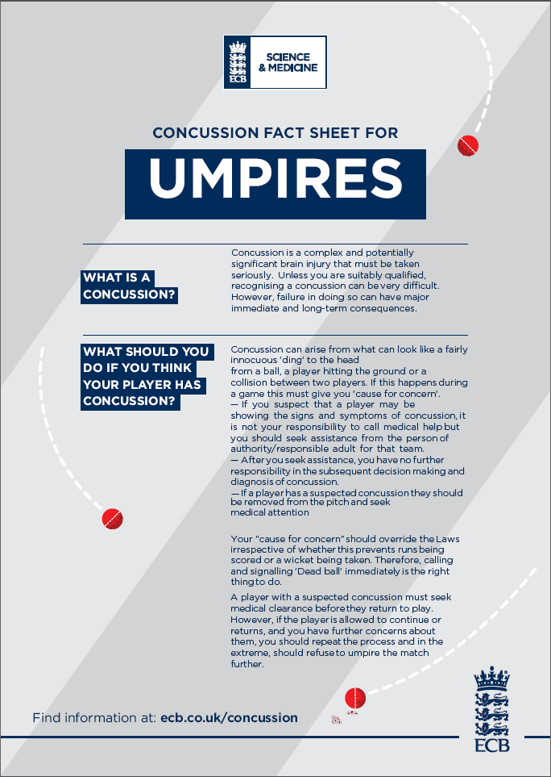

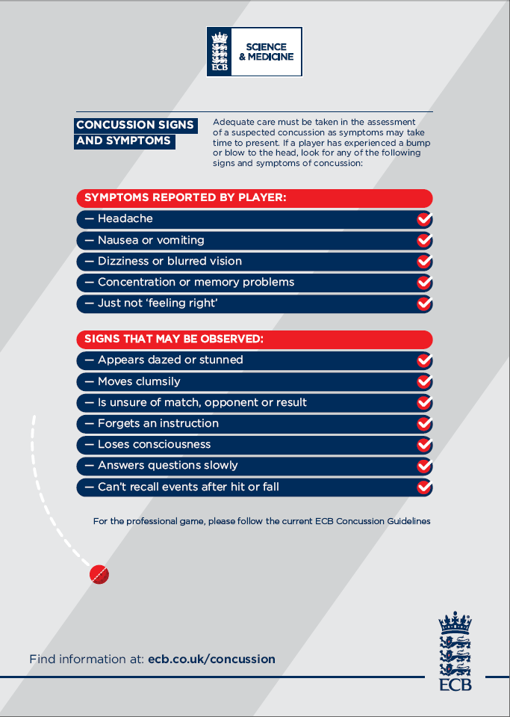

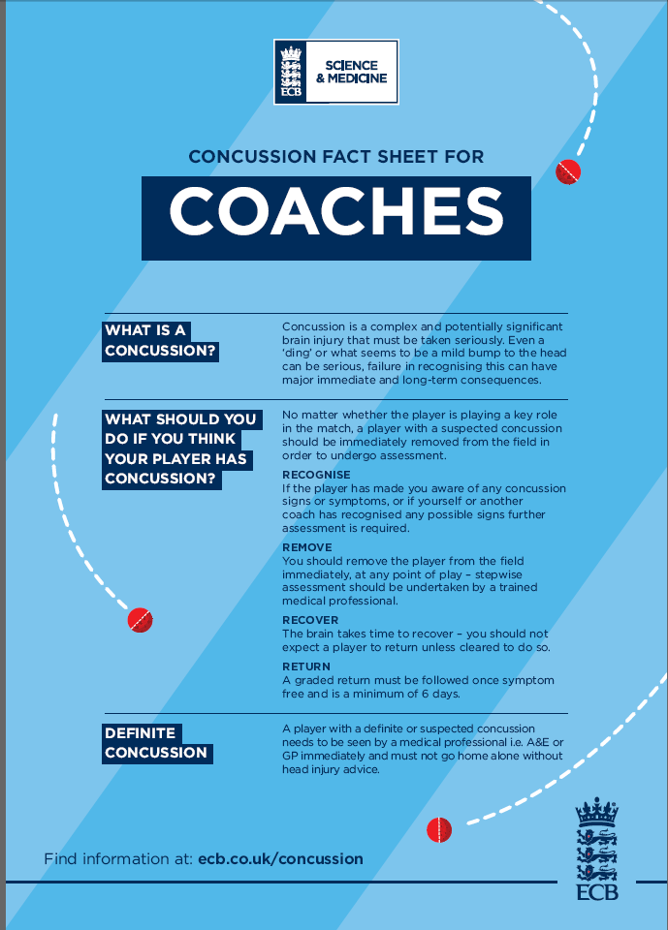

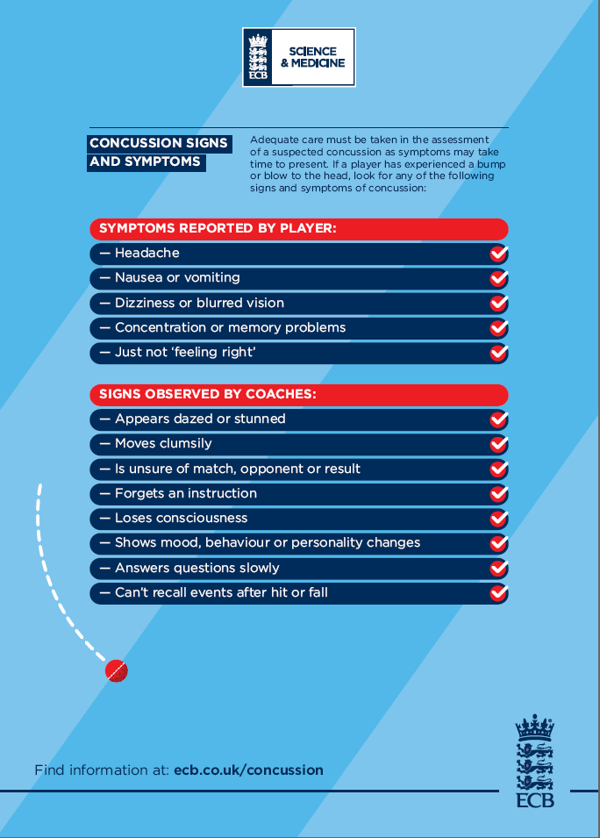

|  |  |
| --- | --- |
|  | ANNEX B TO  ACA SSMP  31 MAR 21 |

**Army Cricket COVID 19 Return to Recreational Cricket Guidance and Direction**

**Introduction**

1. Those responsible for planning, managing or playing Army Cricket at all levels are to ensure that they fully comply with the following:

* ABN 095/2020 – Resumption of Army Sport (and any subsequent updates / amdts).
* FRAGO 001 to Pj PHEONIX OpO 001 – specifically the FHP measures.
* ECB Guidelines on a return to cricket (including updates).
* The detailed guidance provided below.
* Note that in instances where the ECB guidance may be at odds with the Army guidance then the Army guidance will always take precedence.

**Summary**

1. The purpose of these guidelines is to offer practical guidance to players and clubs on the steps they should take to remain safe whilst undertaking recreational cricket activity and informal cricket activity in an outdoor environment. These guidelines currently apply to England only. These guidelines have been produced in line with the UK Government guidance on public spaces, outdoor activity and exercise published on 1 June 2020 and also the ECB and ECB ACO. Recreational cricket has been given a date of 11th July to restart. This covers training and also competitive matches. There is also a section containing specific guidance for officials who will have a clear role in ensuring the safe conduct of cricket.

**All activity must be consistent with the Government guidance regarding health, social distancing and hygiene.**

**Responsibilities of OICs**

1. Every activity (training or competitive fixtures) will be conducted under the control of a nominated OIC. These personnel are to be identified at all level (Army, Corps and Unit) and will normally be the respective Team Manager, Coach or Captain or, in the case of a Unit the OIC Cricket.
2. The nominated OIC is to ensure that for every training session or fixture that:

* All players are to have seen the mandatory FHP briefing. Self-certification is required.
* All admin instructions must refer to COVID-19 and FHP requirements.
* The generic Risk Assessment (Annex A) and the COVID Specific Risk Assessment (Annex C) are to be used and, where necessary, a dynamic Risk Assessment is to be conducted at the location of the event.
* A briefing is given to all personnel (players and officials) before the match starts. This briefing will be delivered by the OIC and / or Lead Official. A list of points to be covered will be provided.
* In order to assist with ‘Test & Trace’ a nominal roll of all players and officials that participated in a fixture / training session is to be recorded and retained by the OIC. This will be retained for a period of 28 days after the end of the season and then destroyed.

**Key Points**

* Maximum of 30 personnel per fixture (including coaches and officials but not including spectators).
* All travel must be in accordance with social distancing and FHP direction.
* No access to changing rooms; must arrive changed and ready.
* Where practical access to ablutions will be available.
* Must comply with protocols on hand washing / sanitising.
* Catering and refreshments will be an individual responsibility.
* Individuals should undergo a personal symptom check prior to all activity and not take part if they demonstrate any COVID-19 symptoms.
* Club representatives should ensure that the facility is compliant with current Government legislation, including legislation and guidance related to COVID-19.
* All activity should include regular hygiene breaks for participants' hands and the ball, e.g. every six overs or 20 minutes.
* Clubs should keep a record of attendees at a match/session, including contact details, to support NHS Test and Trace.
* Players should remain socially distanced at all times (In England only: wicketkeepers and slip fielders at 1m+).
* Players should minimise handling of the ball in all activity, by limiting contact as it makes its way back to the bowler and using small groups in training; no sweat or saliva should be added to the ball at any time.
* Limit the sharing of equipment where possible. Where not possible, practice strict hand hygiene.
* Batters to run in distinct running lanes to ensure they’re not within 2m of the bowler or their batting partner.

**General Considerations and Guidance**

Guidance is provided below as follows:

* ECB Roadmap for the return of recreational cricket Annotated to show our current position)
* Latest guidance from the ECB on a return to playing. – Latest guidance can be found here: <https://resources.ecb.co.uk/ecb/document/2021/03/26/c1d0973a-94d1-410b-a400-826f6a71feb5/Recreational-Cricket-COVID-Guidance-in-England-26.03.21.pdf>
* This guidance was published on 26th March 2021.
* Specific guidance for Officials.
* FAQs.
* Further updates can be found on the ECB Website: <https://www.ecb.co.uk/news/ecb>



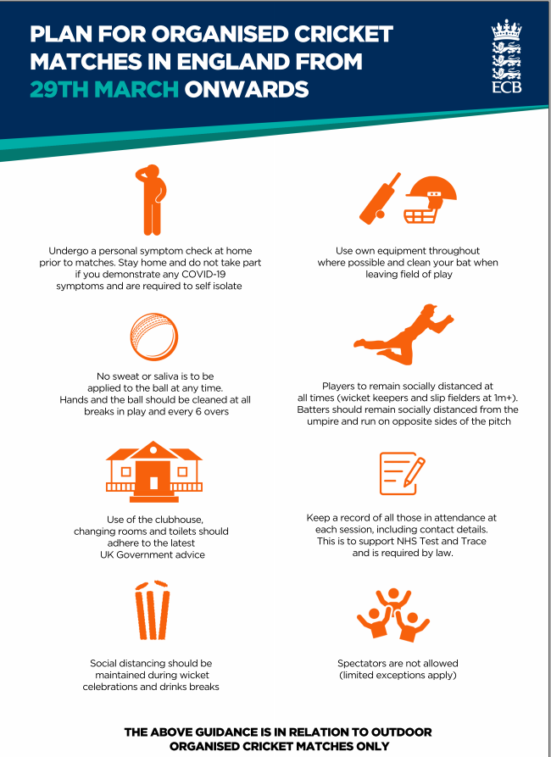

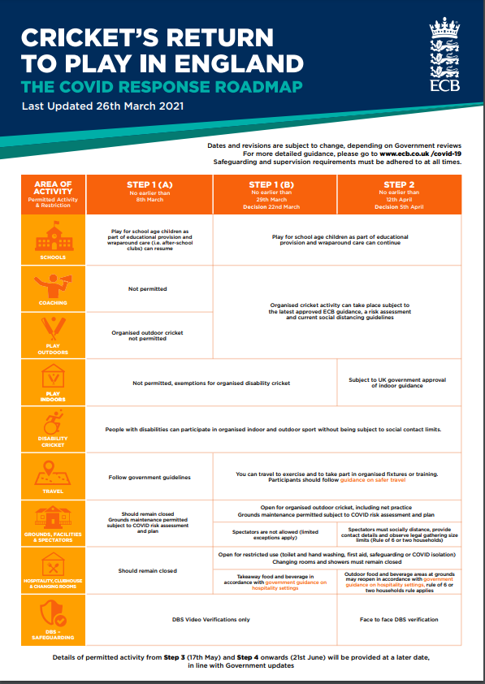

WE

ARE

HERE

1. Further advice is available at the GOV.UK and Sport England websites. Please regularly check these sites and the updated ECB guidance as this policy position is likely to change over time and could also become more regionalised and localised as time progresses.

**ECB ACO GUIDANCE FOR UMPIRES AND SCORERS WHEN OFFICIATING SOCIALLY DISTANCED CRICKET MATCHES - IN ENGLAND**

1. To enable recreational cricket to resume, adapted playing conditions have been introduced and this document details the guidance for umpires and scorers who choose to make themselves available. **It is the duty of the umpires to manage these new adapted playing conditions** and guidance on operating them and any sanctions are also included.
2. This guidance is divided into five sections:

* Before the game – guidance for both Umpires and Scorers
* During the game – guidance for Scorers
* During the game – guidance for Umpires
* Additional Advice for Umpires
* Frequently Asked Questions (FAQs)

Please read this guidance carefully and should you have any queries, please read the FAQs. This guidance applies to **England** only.

**The ECB ACO insurance scheme will cover anyone who chooses to officiate these matches irrespective of whether they are friendly or league matches, providing the games are played in adherence to Government guidance.**

1. Please note the policy covers public liability and personal accident injury but does not cover any illness e.g. COVID-19
2. **Before the game – Umpires and Scorers**

* If you are showing symptoms of COVID-19 do not travel to the game and get a test.
* Officials are encouraged to follow best practice for travel including avoiding use of car sharing and you should arrive changed.
* Please ensure that you bring your own hand sanitiser and food and drink as the clubhouse may not be open.
* On arrival at the ground you will need to provide your name & contact details for NHS Test & Trace.
* The host club are responsible for the implementation of all facility guidelines (including the scorebox) as well as the provision of hand sanitation gel.
* The host club are responsible for setting up the stumps which should also have been sanitised; the umpire is responsible for the provision of the bails.
* To maintain social distancing, batting lines will be created.
* All officials are encouraged to wash their hands/hand sanitise before play starts.

1. **During the game – Scorers**

* Where possible, scoreboxes should not be used.
* As an alternative, the host club to consider providing a gazebo so scorers remain dry even if play continues during light rain.
* Consider using a small portable scoreboard instead of a full scoreboard, or alternatively have only one scorer inside the scorebox, with less frequent updating.
* Scorers should remain socially distant from others at all times and specifically:
* In the scorebox if it is large enough for 2 scorers
* When interacting with any players; ideally players should not be allowed in the scorebox
* When interacting with other officials
* During any interval or break in play
* Equipment should not be shared including laptops and tablets.
* Communal scorebooks which are passed from one person to another should be avoided.
* Scorers will not hold any item of players clothing, sunglasses or any valuables.
* Scorers will not collect/handle team subs.
* Leagues using DLS will be advised to ensure that alternative arrangements are in place to calculate the result in the event that the DLS Par Score Tables cannot be produced electronically. Scorers should ensure that they have pen/paper to produce the necessary manual calculations and the outcome should be verified verbally with the umpires.
* Where Scorer Pro is being used, scorer(s) can produce the relevant Par Score Table and save it as a pdf file that can be emailed to the captains and umpires if this is required.
* Where D/L is being used, the captains should be encouraged to use the Play-Cricket Scorer Apps to calculate the D/L Par Score. Guidance on how to use the App can be found here
* If a walkie-talkie is being used, usage should be kept to a minimum and only used by one of the two scorers. The equipment should be sanitised before use.
* Scorers should either regularly wash their hands or use hand sanitiser.
* In the event of rain, scorers should remain in the score box if that is where they are sitting, or return to their own vehicle if there is insufficient outdoor cover from the rain to maintain social distancing.

1. **During the game – Umpires**

* Umpires should remain socially distant from others at all times and specifically:
* At the toss
* When interacting with any players
* When interacting with other officials
* During any interval or break in play
* Umpires will ensure that all players maintain social distancing during the match and in particular, when players are fielding, discussing tactics, having refreshments or celebrating the fall of a wicket. Batters must remain on their lines.
* No sweat or saliva on the ball is allowed under any circumstances.
* Umpires will not deliberately touch the ball at all during play.
* The ball will be returned direct to the bowler either on the full or rolled along the ground. It should not be passed around the field.
* The umpires will not collect the ball at a fall of a wicket or at any breaks; instead, the ball will be returned to the base of the stumps.
* Only umpires should replace bails and remake the wicket including after any attempted stumpings or run outs.
* Umpires will not provide bowlers markers or cloths for drying the ball.
* Players will be required to sanitise their hands after every 6 overs or 20 minutes whichever is shorter; the umpires should call “time” after every 6 overs or 20 minutes to facilitate this.
* At each break, it will be the responsibility of the fielding Captain to sanitise the ball before play recommences. The umpires should ensure that this happens and manage these breaks by waiting until the end of the over or a fall of a wicket.
* The umpires should sanitise their own hands at every drinks or innings break and after every contact with stumps or bails.
* Umpires will not hold any item of players clothing or sunglasses. They will need to place these themselves beyond the boundary.
* There is no requirement for officials to wear any form of PPE although some individuals may wish to do so.
* Scientific research has shown that there is a minimal risk of infection when the bowler fleetingly passes the umpire so there is no need for the bowler’s end umpire to change his normal position or to move into position once the bowler has passed by.
* Bowlers returning to their mark should maintain social distancing when passing the umpire.
* Bowlers should maintain social distancing when making any appeals.
* If a walkie-talkie is being used, usage should be kept to a minimum and only used by one of the two umpires. The equipment should be sanitised before use.

1. In the event of rain, umpires must remove the stumps and bails before the covers are pulled on. Umpires should return to their own vehicle if there is insufficient outdoor cover from the rain to maintain social distancing.
2. **Additional Advice for Umpires**

* ECB has worked with MCC on the necessity to alter any Laws or Playing Conditions to enable recreational cricket to take place during the COVID-19 pandemic. MCC has clarified that it will not change any of the Laws of Cricket in response to the crisis, feeling that amending Playing Conditions is a better route to take.
* ECB and MCC have discussed how new regulations may be applicable to various levels of the game, and both bodies are pleased to offer the advice below as a means of getting cricket played.
* In order to effectively manage cricket through this phase, Officials will be empowered to ensure measures are adhered to through appropriate interventions designed by the ECB Association of Cricket Officials (ECB ACO). In essence, this means that instances of breaching of the measures will be dealt with Under Law 41 (Unfair Play). However, Law 42 (Unacceptable Conduct) remains as an option if umpires believe conduct is unacceptable.
* Prior to Play – Umpires will have read the ECB guidance and conduct normal pre-match protocols and check pitch for ‘batting line’ markings
* At the Toss – Captains will be advised of their responsibilities for directing their team on and agree the following:
* No sweat or saliva on the ball is allowed
* Players to maintain social distance at all times.
* Ball to be returned directly to the bowler (On the full or rolled along the ground)
* Not to remake the wicket once the ball has become dead, this is the role of the umpire.
* Players to ensure that any drinks, sweaters or other paraphernalia to be placed at least 1m from boundary edge where at all possible.
* Players understand the batting lines.
* Hygiene breaks will take place every 6 overs or 20 minutes whichever is sooner (A wicket break can be used to restart the process).
* Captains should be made aware that any breach of the above could result in a first and final warning and any subsequent transgression will result in the award of 5 penalty runs.
* During Play – Umpires will not deliberately come into contact with the ball. Any breach of 1-7 above, will result in a first and final warning, under Law 41.
* If deemed Unacceptable Conduct, penalties under Law 42 shall apply.
* A player intentionally moving within 1 metre of anyone else for non-cricketing purposes will be treated as a Level 3 offence
* A player intentionally spitting or coughing at and within 2 metres of, another person will be treated as a Level 4 offence
* After Play – Umpires are to leave the stumps in the ground, bails on the ground (if they’re not their own) next to the stumps and leave bowling markers for the Club Representative to collect.

1. **NHS Test and Trace**

Clubs and venues providing cricket activities are required to keep a record of all visitors, customers and staff at the venue, to support NHS Test and Trace. They must:

* Ask every participant (including players, match officials and coaches) to provide their name and contact details.
* Ask at least one member of every party of customers or visitors (up to 6 people) to provide their name and contact details.
* Keep a record of all staff and volunteers working on their premises and shift times on a given day, and their contact details.
* Keep these records of customers, visitors and staff for 21 days and provide data to NHS Test and Trace, if requested.
* Display an official NHS QR code poster, so that customers and visitors can ‘check in’ using this option, as an alternative to providing their contact details. (Please note that the NHS QR code is an alternative to providing contact details - if someone chooses not to scan the NHS QR code using the NHS COVID-19 app, you are still legally required to record and maintain their contact details as per above).
* Ensure you manage this information in line with data protection regulations.

1. **Frequently Asked Questions (FAQs)**

* In the event there is a local lockdown and cricket is suspended, would I still be insured if I officiated at a match during the lockdown?

No. You would not be covered as it would in contravention of Government guidelines.

* I am over 70, am I allowed to umpire or score?

Please refer to the latest Government guidelines which you can find here

* Can my league make me umpire if I don’t want to?

No-one can force you to do so. ECB ACO have suspended umpire grading for 2020 so your grading will not be affected if you do not umpire.

* What about the coin toss?

It is the responsibility of the home team Captain to provide the coin and for umpires to supervise the coin toss. The toss should be completed whilst complying with social distancing.

* Who is responsible for the spare balls?

The host club will provide sanitised spare balls and they should be left off the field until needed. The chosen spare ball should be cleaned by the fielding Captain before use.

* Should a player apply sweat or saliva to the ball, either deliberately or out of habit, is the ball to be changed for a spare?

The umpire should ask the fielding captain to sanitise the ball and play recommences with the existing ball.

* When operating with ‘batting lines’ whose responsibility is it to move when a fielder may be stationed in direct line of the runner?

The batter must avoid the fielder. The fielder must not impede the batter when running unless moving to field the ball or back-up a throw.

* If a player fails to run within a ‘batting lane’ what does the umpire do?

This is covered under Point 2 in the additional advice for umpires (At the Toss) and can be covered under Law 41 Unfair Play

* Where does the ball need to be once a wicket has fallen?

At the bowlers’ end by the stumps.

* During rain breaks who is responsible for the ball in use?

Fielding team Captain.

* Our scoreboard is a manual one with strings to pull and it takes two scorers to work all the numbers. What should I do?

If you have to use that scoreboard only one scorer should be seated inside if you cannot sit 1m+ apart. Only display the minimum requirement, which is total runs, wickets, and overs.

* I use a Linear back-up sheet when I score on PCS Scorer PRO. Should I still do that?

You should bring a pre-prepared sheet with you and ensure that you are the only person handling that sheet. No printing should be done at the match.

* I’m concerned that if I score from a gazebo or outside the scorebox, I will not be able to stop players coming to look over my shoulder at their statistics.

The guidance is clear. Players must refrain from approaching scorers and should maintain social distancing at all times.

* Who can I contact for any other questions?

Please email any further questions to [ecb.aco@ecb.co.uk](mailto:ecb.aco@ecb.co.uk)

1. If you have any further questions, please contact AD Safety – WO2 Alex Rennie on 07921383539

|  |  |  |  |  |  |  |  |  |  |  |  |  |  |  |  |  |  |  |  |  |  |  |  |  |  |  |  |  |  |  |  |  |  |  |  |  |  |  |  |  |  |  |  |  |  |  |  |  |  |  |  |  |  |  |  |  |  |  |  |  |
| --- | --- | --- | --- | --- | --- | --- | --- | --- | --- | --- | --- | --- | --- | --- | --- | --- | --- | --- | --- | --- | --- | --- | --- | --- | --- | --- | --- | --- | --- | --- | --- | --- | --- | --- | --- | --- | --- | --- | --- | --- | --- | --- | --- | --- | --- | --- | --- | --- | --- | --- | --- | --- | --- | --- | --- | --- | --- | --- | --- | --- |
| **Key Guidance** This section provides a quick overview of some of the key concepts in Army risk assessment. Refer to Notes section for further information. The first line of the risk assessment table, below, shows an illustrative example.  **Hazard** is anything that may cause harm, e.g. working at height on a ladder.  **Risk** is the chance that someone or something could be harmed by the hazard, measured by combining (multiplying) the likelihood of it happening with its impact (severity). For example, there may be a ‘possible’ likelihood that someone that is not competent could fall from a ladder (3 rating – see right) combined with a ‘moderate’ impact of multiple injuries (2 rating), which creates a score of 6 (low risk). However, the risk should be reduced to as low as reasonably practicable (ALARP) through the implementation of control measures, such as ensuring that only trained people climb the ladder.  **Dynamic Risk Assessment** compliments generic and specific risk assessment. Regardless of completing this AF 5010, it is beholden on the person creating the risk to continue to monitor the activity and the control measures. Any changes to the activity (including the environmental conditions) or the control measures, must be addressed via the mechanism of a dynamic risk assessment such that risks remain ALARP.  Note however that persons undergoing training cannot be deemed competent until their capability is properly assessed | | | | **Likelihood (L)** | | **Multiplied by** | **Impact (I)** | **Equals** | |  |  |  |  |  |  |  | | --- | --- | --- | --- | --- | --- | --- | | **Risk Score Calculation** | | | | | | | |  | | **Likelihood** | | | | | | **1** | **2** | **3** | **4** | **5** | | **I**  **m**  **p**  **a**  **c**  **t** | **5** | **5** | **10** | **15** | **20** | **25** | | 4 | **4** | **8** | **12** | **16** | **20** | | **3** | **3** | **6** | **9** | **12** | **15** | | **2** | **2** | **4** | **6** | **8** | **10** | | **1** | **1** | **2** | **3** | **4** | **5** | | |
| 1 – Remote / Rare  2 – Unlikely  3 – Possible  4 – Probable  5 – Highly Probable  (Almost Certain) | | 1 – Minor  2 – Moderate  3 – Major  4 – Severe  5 – Critical  *Note: impact number is unlikely to change with control measures* |
| **5 Step Process** | Step 1 – Identify the hazards | Step 2 – Decide who might be harmed and how | Step 3 – Evaluate the risks and decide  on precautions (control measures) | | Step 4 – Record your significant findings and include in Ex / Coord instructions as necessary. Implement control measures | | | | | Step 5 – Review your risk assessment and update as necessary |

|  |  |  |  |
| --- | --- | --- | --- |
| **Dept / Sub-Unit / Unit / Formation:** | Army Cricket | **Assessor (No, Rank, Name):** | WO2 A Rennie / ACA Committee Members |
| **Activity (SSW) / Exercise (SST):** | Army Cricket Training and Cricket Matches at Aldershot Cricket Ground GU11 2ET | **Assessor’s signature:** | Electronically Signed |
| **Generic or Specific Risk Assessment:** | Specific for Aldershot | **Assessment Date:** | 21 Jul 20 |
| **Relevant Publications / Pamphlets / Procedures:** | JSP 660, AGAI Vol 1 Chapter 5 Sport, ABN 095 2020 – COVID-19 – Resumption of Sport, ACO 2020 -20 dated Feb 20, ECB & ECB ACO Return to play Guidance and Direction | **Review Date** **for GRA** (Step 5)**:** | Annually |

| (a) | (b) | (c) | (d) | (e) | (f) | (g) | (h) | (i) | (j) | (k) | (l) | (m) | (n) |
| --- | --- | --- | --- | --- | --- | --- | --- | --- | --- | --- | --- | --- | --- |
| **Ref** | **Activity / element**  (Step 1a) | **Hazards identified**  (Step 1b) | **Who or what might be harmed and how**, e.g.  • Military personnel - fatality  • Civ staff / contractors - injury  • General public - injury • Environment - spill(Step 2) | **Existing control measures**  (Step 3a) | **Assessment with  existing controls** | | | **Is residual risk acceptable in the context of risk appetite for the activity?  (Yes / No) – Refer to Risk Score Calculation above** *If Yes, move to column (n). If No, identify  additional controls* (Step 3e) | **Reasonable additional controls that can be implemented to reduce risk  to ALARP** (Step 3f) | **Reassessment with additional  control measures** | | | **List required action(s)  to instigate controls** (Step 3j) |
| **L  (1 to 5)** (Step 3b) | **I (1 to 5)** (Step 3c) | **Score  (L x I)** (Step 3d) | **L  (1 to 5)** (Step 3g) | **I (1 to 5)** (Step 3h) | **Score  (L x I)** (Step 3i) |
| 1 | Cricket Training & Matches | **Training Balls** | Military Personnel – Injuries/contamination. | Common contact point for all players when Bowling or Batting | 1 | 2 | 2 | Yes | Each bowler must be issued with his own ball. These balls must not be shared | 1 | 1 | 1 |  |
| 2 | **Stumps** | Common contact point for batsmen | 1 | 2 | 2 | Yes | Stumps must be sterilised at the end of each batters innings | 2 | 1 | 2 |  |
| 3 | **Cricket equipment** | Common contact point for all players | 1 | 1 | 1 | Yes | We recommend using your own equipment if possible. If equipment is being shared, please follow UK Government’s guidance on the sharing of equipment. | 1 | 1 | 1 |  |
| 4 | **Cricket Nets** | Common contact point for all players and area for social distancing | 1 | 1 | 1 | Yes | Nets should be used on an ‘every other’ basis, leaving one net free between nets. Note that for nets within a security fence, occupancy numbers could be limited by social distancing requirements. | 1 | 1 | 1 |  |
| 5 | **Cricket coaches** | Social Distancing concerns | 1 | 1 | 1 | Yes | Cricket coaches, can now undertake small group sessions of up to six (6) people including the coach (1:5) and they must comply with ECB safeguarding policies (as well as being able to conduct one-to-one coaching). | 1 | 1 | 1 |  |
| 6 | **Players** | Social Distancing concerns | 2 | 3 | 6 |  | • Seek confirmation from the club that it has reopened and make a booking.  • Check for symptoms of COVID-19. In line with current Government guidance, if you are symptomatic, and/or living in a household with a possible COVID-19 infection, you should remain at home and follow Government guidance.  • Follow UK Government guidance on shielding and protecting people who are clinically extremely vulnerable from COVID-19 if it applies to you.  • Avoid public transport if at all possible. | 1 | 2 | 2 |  |
| 7 | **Host Club (Match Day)** | Social Distancing concerns | 2 | 2 | 4 |  | - On arrival at the ground you will need to provide your name & contact details for NHS Test & Trace.  - The host club are responsible for the implementation of all facility guidelines (including the scorebox) as well as the provision of hand sanitation gel.  - The host club are responsible for setting up the stumps which should also have been sanitised; the umpire is responsible for the provision of the bails.  - To maintain social distancing, batting lines will be created. | 1 | 1 | 1 |  |
| 8 | **Players Match Day** | Social Distancing concerns | 3 | 3 | 9 | Yes | All Of Ser 6 plus maintain social distance guidelines. | 2 | 2 | 4 |  |
| 9 | **Umpires Match Day** | Social Distancing concerns | 3 | 3 | 9 | Yes | Follow ECB ACO Guidance as published in the ACA SSMP | 2 | 2 | 4 |  |
| 10 | **Scorers Match Day** | Social Distancing concerns | 3 | 3 | 9 | Yes | Follow ECB ACO Guidance as published in the ACA SSMP | 2 | 2 | 4 |  |
| 11 | **Match Ball** | Common contact point for all players when Bowling or Batting | 1 | 2 | 2 | Yes | No saliva or sweat should be applied to the ball at any time.  Sanitised after every 6 overs or 20 mins  Home team captain is responsible for all match ball duties | 1 | 1 | 1 |  |
| 12 | **Score Boxes** | Social Distancing concerns and contact issues | 3 | 3 | 9 | Yes | 1. Where possible, scoreboxes should not be used.  o As an alternative, the host club to consider providing a gazebo so scorers remain dry even if play continues during light rain.  o Consider using a small portable scoreboard instead of a full scoreboard, or alternatively have only one scorer inside the scorebox, with less frequent updating. | 2 | 2 | 4 |  |
| 13 | **Pavilion / Clubhouse** | Social Distancing concerns and contact issues | 3 | 3 | 9 | Yes | Clubhouses can be reopened in a limited way for operational reasons (e.g. for access to first aid equipment) or for toilet access (see below) **but all communal areas including bar, changing rooms etc. are to remain closed for general use.**  Toilet facilities can be opened if the venue wishes, but particular care should be taken by those using them and those cleaning them. Where they are open, venues must ensure soap and water is provided and they are cleaned regularly. | 2 | 2 | 4 |  |
| 14 | **Gates** | Common contact point for all players when opening and closing | 2 | 2 | 4 | Yes | Gates will where possible be left open during working hours. Gates will be decontaminated by staff on a regular basis. | 1 | 2 | 2 |  |
| 15 | **Benches and Seats** | Common contact point for all players if resting or waiting between playing holes. | 2 | 1 | 2 | Yes | Taped up to prevent use. | 1 | 1 | 1 |  |
| 16 | **Security Locks** | Common point of contact when entering the clubhouse and other areas within the clubhouse | 3 | 3 | 9 | Yes | Where this cannot be achieved essential security doors and locks will be cleaned with disinfectant on a regular basis. | 2 | 2 | 4 |  |
| 17 | **Other Clubhouse**  **Doors** | Common point of contact when moving through the clubhouse. | 3 | 3 | 9 | Yes | The clubhouse and all general public areas will remain closed until further notice  A clearly visible sign placed at entry points restricting entry only to essential staff for administrative purposes.  Door handles and contact points will be decontaminated on a regular basis. | 2 | 2 | 4 |  |
| 18 | **Other Players** | Players making contact shaking hands, embracing, standing next to each other.  Being in close proximity where one player can contaminate another with exhalation of pathogen bearing droplets. | 3 | 3 | 9 | Yes | All players Have been issued with strict guidelines on revised cricket etiquette and social behaviour  Ground staff will plan work to avoid contact and observe good social distancing at all times. – Ensure running lines are added to the pitch markings  See ECB & ECB ACO Return to play guidance | 2 | 2 | 4 |  |
| 19 | **Ground Staff** | Players coming into close contact with ground staff. | 2 | 3 | 6 | Yes | 2 | 2 | 4 |  |
| 20 | **Visitors and**  **Deliveries** | Players coming into close contact with clubhouse visitors or delivery staff. | 2 | 2 | 4 | Yes | 1 | 1 | 2 |  |
| 21 | **Members of the**  **Public** | Players coming into close contact with members of the public on the cricket pitch and general area | 3 | 3 | 9 | Yes | 2 | 2 | 4 |  |
| 22 |  | **Travel to and from Activities** | Military Personnel – injury / fatality | Routine risk of travel under ‘normal’ circumstances but compounded by COVID-19 and social distancing measures.  All personnel are to comply with the extant restrictions on travel arrangements.  Where military transport is provided then JSP800 is to be adhered to.  Specific details on travel are included in admin instructions for activities. | 2 | 2 | 4 | Yes | All personnel are to comply with the extant restrictions on travel arrangements.  Where military transport is provided then JSP800 is to be adhered to.  Individuals should not travel if they or any of their household members are showing coronavirus symptoms or are self-isolating because a household member is showing symptoms.  Individuals should continue to remain vigilant of their own personal safety when travelling. The direction and advice on travelling for Defence activity will be reviewed as HMG advice changes.  Where possible individuals should avoid the use of public transport (i.e. use of buses, minibuses, coaches, trains etc.) and support social distancing rules by travelling using a privately-owned vehicle, bicycle or by walking.  If public transport must be used, individuals should maintain social distancing rules wherever possible and wear a face covering, as required by the operator.  Individuals should minimise the use of shared Defence-owned transport (including MT) where possible and support social distancing rules by travelling using private transport (a privately owned vehicle, bicycle or by walking). Where the use of Defence-owned vehicles is required, it should be subject to a risk assessment and applied mitigation measures to minimise the transmission of COVID-19 for both users and passengers.  The use of civilian company supplied vehicles (e.g. hire vehicles) is to be minimised to help reduce the transmission of COVID-19. If hire vehicles are required, they should be used in accordance with the company policy regarding COVID-19. | 1 | 2 | 2 |  |
|  |  | **Accommodation** | Military Personnel | All personnel are trained in their respective roles.  Personnel are aware of signs and symptoms of fatigue and take regular breaks from the screens.  Water is not to be used around electrical equipment  All cables are to be kept tidy and a cable tidy used if they pose a risk to trip over them.  Personnel are to comply with JSP 375 - leaflet 12 (Safety when working with electricity or electrical equipment), Leaflet 17 (Office safety) & Leaflet 27 (First Aid at Work).  Contractor carryout annual safety checks on registered equipment.  All equipment (personal or authorised) must be registered with SpO.  All computers and equipment are to be serviced and maintained.  All equipment used is in serviceable condition with means of exchanging if necessary.  ETS SSoW in place.  All visitors to working areas are escorted and briefed on arrival.  Lighting available around the site.  First Aider on site within ETS & ADT Team Manager is in date Team Medic, FPOS & MIRA.  Personnel are to work in accordance with the WBGT readings and DATR heat illness/cold injury policy. The WGBT results are emailed to ETS HQ Staff from the guardroom and then displayed on the notice board throughout the day.  All personnel are to comply wih the DATR Fire Plan.  All personnel are to comply with the DATR Security Plan.  All personnel are to be aware of and comply with the DATR Stress Policy.  Staff are to be able to recognise the signs of fatigue in others.  Regular rest periods.  Persons encouraged to increase fluid intake (non-alcoholic)  In confined spaces a one way system must be observed.  Personnel must wash their hands frequently with the handwash provided within the toilets or if available the hand sanitiser around ETS.  Personnel must not share equipment. If there is a need to share equipment it must be disinfected before used. | 2 | 2 | 4 | Yes | The use of accn will be minimised and, where possible, overnight stays will not be made. Where there is a need for overnight accn then only that accn which complies with social distancing guidelines will be used. For Army teams this will primarily be St Omer Barracks.  Team Managers / OICs will ensure that only suitable accn is used. In cases where daily travel is not possible, if suitable accn cannot be provided then activities will not take place.  Distancing should be implemented min of 2 meters.  Pre-attendance FHP Mandatory workplace brief given and documented for all attendees  Additional FHP Safety brief delivered on site prior to commencement of training.  COVID Health screening done prior to and during attendance of the event.  If personnel suspect they are symptomatic they are to immediately self-isolated and notify the Team Manager who will follow the IA Suspected COVID procedure outlined in Annex E of the AI.  In confined spaces the one-way system is to be observed.  Comply with the DATR COVID 19 action plan direction from the HQ.  Comply with DATR COVID 19 Site Specific Risk Assessment.  Observe correct coughing etiquette.  Apply direction from NHS and the government.  Washing of hands to be done as directed by the government. All toilets are to have handwash be made available.  Hand washing stations are situated around ETS.  Personnel must not share equipment. If there is a need to share equipment it must be disinfected before used by any person.  Hot desking is not permitted. Classroom based lessons have significant breaks between each lesson to allow personnel to disinfect and leave the room before the next wave of personnel arrive.  No more than 6 personnel in a classroom with desks pre-spaced 2m apart and safety instructions to ensure desks are not moved, are wiped down prior to and after the session and windows are open for improved ventilation.  Personnel are to ensure they wash their hands frequently, especially before and after procedures. | 1 | 2 | 2 | Team Managers and OICs to ensure that (where necessary) accn is considered in planning and contained in respective admin instrs.  Monitor current direction from the MOD and government.  Continue to monitor and if needs be re asses.  All personal to keep an eye on each other for showing of symptoms. |

|  |  |  |  |  |
| --- | --- | --- | --- | --- |
| **Authorising Officer / Warrant Officer (at unit level)** | **No, Rank, Name** | **Post** | **Date** | **Signature** |
| **Existing and additional controls agreed** |  |  | Jul 20 |  |
| **Where risk is elevated up the CoC, CO to confirm additional controls implemented** |  |  |  |  |

**NOTES**

|  |  |  |  |  |  |  |  |  |  |  |  |  |  |  |  |  |  |  |  |  |  |  |  |  |  |  |  |  |  |  |  |  |  |  |  |  |  |  |  |  |  |  |  |  |  |  |  |  |  |  |  |  |  |  |  |  |  |  |  |  |
| --- | --- | --- | --- | --- | --- | --- | --- | --- | --- | --- | --- | --- | --- | --- | --- | --- | --- | --- | --- | --- | --- | --- | --- | --- | --- | --- | --- | --- | --- | --- | --- | --- | --- | --- | --- | --- | --- | --- | --- | --- | --- | --- | --- | --- | --- | --- | --- | --- | --- | --- | --- | --- | --- | --- | --- | --- | --- | --- | --- | --- |
| Risk = Likelihood x Impact   |  |  |  | | --- | --- | --- | | **Likelihood** | | **Definition** | | **5** | **Highly Probable  (Almost Certain)** | Is expected to occur in most circumstances | | **4** | **Probable** | Will probably occur at some time, or in most circumstances | | **3** | **Possible** | Fairly likely to occur at some time, or some circumstances | | **2** | **Unlikely** | Is unlikely to occur, but could occur at sometime | | **1** | **Remote / Rare** | May only occur in exceptional circumstances |  |  |  |  | | --- | --- | --- | | **Impact** | | **Definition (Health Safety and Environment)** | | **5** | **Critical** | * Multiple fatalities or permanent, life changing injuries. * Permanent loss or damage beyond remediation of an important and publicly high-profile natural resource, area or species. * Multiple incidents causing a major environmental impact. | | **4** | **Severe** | * A single death or multiple life-threatening injuries. * Severe damage over a wide area and/or on a prolonged basis to a natural resource, including controlled waters, or geography requiring multi-year remediation. * Single incident causing a major environmental effect or multiple incidents causing significant effect. | | **3** | **Major** | * Single life changing injury or multiple injuries which have a short-term impact on normal way of or quality of life. * Moderate damage to an extended area and/or area with moderate environmental sensitivity (scarce/ valuable) requiring months of remediation. * Single incident causing significant environmental impact. | | **2** | **Moderate** | * Multiple injuries requiring first aid. * Moderate damage to an area, and that can be remedied internally. * Multiple incidents causing minor environmental effect. | | **1** | **Minor** | * An Injury requiring first aid * Limited short-term damage to an area of low environmental significance/ sensitivity * Incidents causing minor environmental impacts | | Step 5 - Review the generic risk assessment and update if necessary - All generic risk assessments should be regularly reviewed at a frequency proportional to the risk prior to any controls being proposed. In practice generic risk assessments should be reviewed at least annually, or more frequently:  • where required by local instructions/procedures;  • if the safe execution of the activity relies on stringent supervision and/or adherence to a safe system of work;  • if there is reason to doubt the effectiveness of the assessment.  • following an accident or near miss.  • following significant changes to the task, process, procedure, equipment, personnel or management.  • following the introduction of more vulnerable personnel (e.g. persons under 18 or pregnant persons).   |  |  |  | | --- | --- | --- | | **Risk Management** | | | | **Risk Rating** | **Authorisation** | **How Risk should be managed** | | **1 – 3 (Very Low)** | **Assurance Offr** | **Review periodically** to ensure conditions have not changed and working within ALARP and risk appetite. | | **4 – 9 (Low)** | **DASCB** | | **10 – 12**  **(Medium)** | **OF5 /  HQ RC** | **Good risk mitigations** to ensure that the impact remains ALARP and tolerable. Re-assess frequently to ensure conditions remain the same. | | **15 – 16 (Medium to High)** | **HQ RC** | **Requires active management** – review of desired outcome with additional resources or change to output requirements. | | **20 (High)** | **3* – HQ HC & FA** | **Contingency plans** may suffice together with limited risk mitigations to achieve risk ALARP and tolerable. | | **25 (Very High)** | **4* – CGS, Army HQ** | **Operational capability** where the required outcome impacts on defined military capability. | |

Any player who shows signs of the virus at the venue will be instructed to leave and return home immediately.

In the eventuality of any player or other person being overcome to the extent that they cannot take themselves home, staff or other players will call 111 and take advice from the helpline. If an ambulance has to attend the venue, it will be met and taken to the necessary location by a member of staff.

1. The extant version is available on the ASCB website <https://armysportcontrolboard.com/wp-content/uploads/2018/12/20180917-ASCB_Directive_Sep_18.pdf>. A new version is pending.
2. Representative level includes Corps and Army representation.
3. England Cricket Board (ECB) is the National Governing Body (NGB) for Cricket.
4. Major events include the Inter Corps Power Cup, Inter Corps T20 Comp, Army Major and Minor Unit Competition and UKAF events when hosted by the Army.
5. The minimum standard for an umpire is ‘Stage 1 & 2’ - courses are run annually through the ASPT and all officials are managed by UKAFCA ACO.
6. England Cricket guidance for players and cricket pitches is available from the England Cricket Board and is also contained within the Army Cricket Handbook (Ref D).